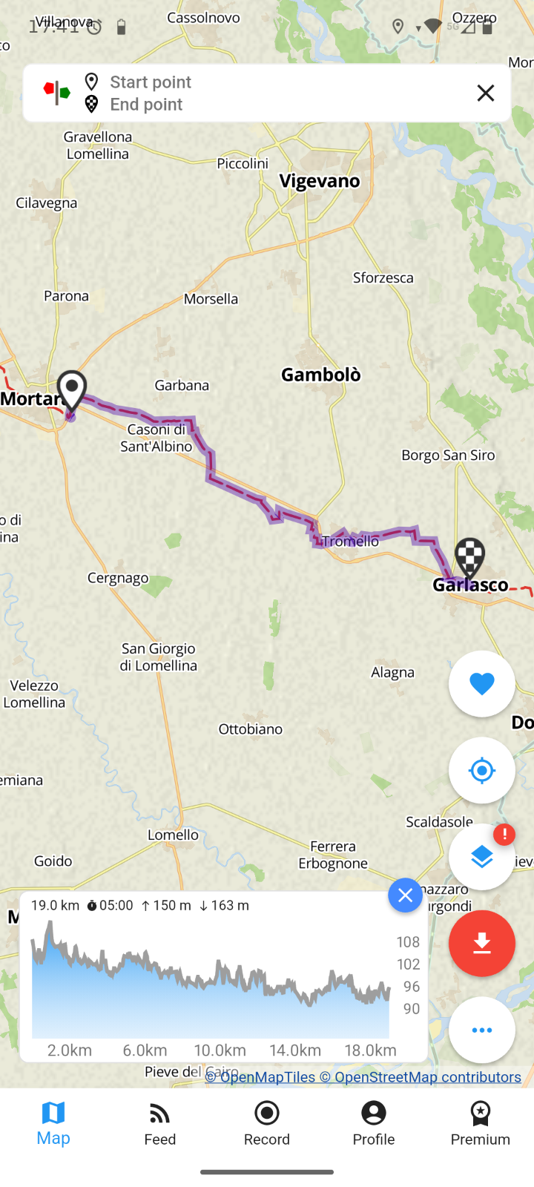
17. Mortara – Garlasco
17th^{th} June

Accommodation

Albergo il Pino
Address: Corso Cavour 1, 27026, Garlasco, Pavia, Italy
Phone Numbers: +39 0382822265
Email: ilpinogarlasco@tin.it
. 6 rooms on the Via Francigena route

Casa del Pellegrino
Address: Via SS Trinità n 6, 27026, Garlasco, Pavia, Italy
Phone Numbers: +39 0382801009+39 3343435810
Email: bibliogarlasco@yahoo.it
Hostel, No. of beds available 4 single beds, 1 bunk bed for a total of 6 beds
All year round upon reservation at least 24 hours in advance
Prices: Donation

